Title (style: biodesign_title)
F. Author,^{*,1} S. Author,² T. Author,² and F.T. Author³_leave blank until camera-ready (style: biodesign_authors)

¹First Division, Organization, City, Pincode, State, Country_leave blank until camera-ready (style: biodesign_affiliations)
² Second Division, Organization, City, Pincode, State, Country_leave blank until camera-ready
³ Fourth Division, Organization, City, Pincode, State, Country_leave blank untilcamera-ready

* Author for correspondence. Email: first.author@address.edu leave blank until camera read

Article-type (Full paper, Pictorial, Long Abstract for Demo)

Keywords:
keyword entry 1, keyword entry 2, keyword entry 3 (between 3 and 5 keywords) (style: biodesign_keywords)
Abstract
Insert abstract text here. Lorem ipsum dolor sit amet, consectetur adipiscing elit, sed do eiusmod tempor incididunt ut labore et dolore magna aliqua. Lorem ipsum dolor sit amet, consectetur adipiscing elit, sed do eiusmod tempor incididunt ut labore et dolore magna aliqua. Lorem ipsum dolor sit amet, consectetur adipiscing elit, sed do eiusmod tempor incididunt ut labore et dolore magna aliqua. Lorem ipsum dolor sit amet, consectetur adipiscing elit, sed do eiusmod tempor incididunt ut labore et dolore magna aliqua. Lorem ipsum dolor sit amet, consectetur adipiscing elit. Lorem ipsum dolor sit amet, consectetur adipiscing elit. Lorem ipsum dolor sit amet, consectetur adipiscing elit, sed do eiusmod tempor incididunt ut labore et dolore magna aliqua. Lorem ipsum dolor sit amet. (Maximum 150 words for full papers and pictorials; demo submission consists instead of a long abstract of 500 words to fill in this box) (Style: biodesign_abstract)

Impact Statement
Some Cambridge Journals (such as our Prisms journals) require an Impact Statement section. Comment out this section if it is not required. a short summary on the wider beneficial use of the research presented in your article. This statement should give a broader perspective on the contribution this research is making to the field. The reported impact can be local, regional, or international in its reach. Impact statements should not exceed 300 words and be comprehensible to a broad, potentially non-academic audience.

Insert A head here (style: biodesign_heading 1)
This demo file is intended to serve as a “starter file”. It is for preparing manuscript submission only, not for preparing camera-ready versions of manuscripts. Manuscripts will be typeset for publication by the journal, after they have been accepted. Lorem ipsum dolor sit amet, consectetur adipiscing elit, sed do eiusmod tempor incididunt ut labore et dolore magna aliqua. Lorem ipsum dolor sit amet, consectetur adipiscing elit, sed do eiusmod tempor incididunt ut labore et dolore magna aliqua. Lorem ipsum dolor sit amet, consectetur adipiscing elit, sed do eiusmod tempor incididunt ut labore et dolore magna aliqua. Lorem ipsum dolor sit amet, consectetur adipiscing elit, sed do eiusmod tempor incididunt ut labore et dolore magna aliqua. On the Latex template, page 1 ends here.

Insert B head here (style: biodesign_heading 2)
Subsection text here. Lorem ipsum (Bayer-Santos et al. 2013) dolor sit amet, consectetur adipiscing elit, sed do eiusmod tempor incididunt ut labore Adade, Castro, and Soares (2007) et dolore magna aliqua. Lorem ipsum dolor sit amet, consectetur adipiscing elit, sed do eiusmod tempor incididunt ut labore et dolore magna aliqua.
Lorem ipsum dolor sit amet, consectetur adipiscing elit, sed do eiusmod tempor incididunt ut labore et dolore magna aliqua. Lorem ipsum dolor sit amet, consectetur adipiscing elit, sed do eiusmod tempor incididunt ut labore et dolore magna aliqua.
Insert C head here (style: biodesign_heading 3)
Subsubsection text here. Lorem ipsum dolor sit amet, consectetur adipiscing elit, sed do eiusmod tempor incididunt ut labore et dolore magna aliqua. Lorem ipsum dolor sit amet, consectetur adipiscing elit, sed do eiusmod tempor incididunt ut labore et dolore magna aliqua. Lorem ipsum dolor sit amet, consectetur adipiscing elit, sed do eiusmod tempor incididunt ut labore et dolore magna aliqua.
Lorem ipsum dolor sit amet, consectetur adipiscing elit, sed do eiusmod tempor incididunt ut labore et dolore magna aliqua. Lorem ipsum dolor sit amet, consectetur adipiscing elit, sed do eiusmod tempor incididunt ut labore et dolore magna aliqua. Lorem ipsum dolor sit amet, consectetur adipiscing elit, sed do eiusmod tempor incididunt ut labore et dolore magna aliqua.

Figures & Tables
Authors are ebncouraged to insert the actual figures and captions in the text, but they should still submit the figures as separate files (unless using LaTeX). Cambridge recommends that only TIFF, EPS, or PDF formats are used for electronic artwork. For more detailed guidance on the preparation of illustrations, pictures and graphs in electronic format please see the Cambridge Journals Artwork Guide (n.d). Especially for Pictorial submissions we advise the use of LaTeX / Overleaf, as they allow authors to embed figures directly within the template provided by Cambridge Journals, ensuring more control over their placement.
All figures must:
- Be supplied as separate files, unless you are using LaTeX.
- Be supplied in our preferred file formats, at final publication size or greater and at the correct resolution for the image type. We cannot improve overall appearance and resolution.
- Be numbered in the order they appear in the manuscript.
- Be named in a logical way (e.g. [First author surname]Fig1.tif).
- Be cited in the main text of the article.
- Have captions supplied at the end of the manuscript text, instead of as part of the figure file.
- Have all relevant copyright permissions cleared.
- Resolution: colour and black and white halftone images must be saved at 300 dpi (dots per inch) at approximately the final size. Line drawings should be saved at 1000 dpi, or 1200 dpi if very fine line weights have been used. Combination figures must be saved at a minimum of 600 dpi.
- If in any doubt, submit the source files that were used to create your figures.
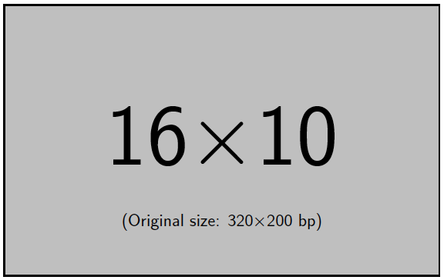
Figure 1. Insert figure caption here (style: biodesign_figure caption)
The output for a single-column figure is in Figure 1 (style: biodesign_figure). Tables should be supplied as separate, editable files, with the exception of authors using LaTeX (in which case tables can be embedded with the usual 'table' and 'tabular' environments). See example in table 1.
Table 1. An Example of a Table (style: biodesign_table caption)
Column head 1 | Column head 2 | Column head 3 | Column head 4
One | Two | Three three | Four
Three | Four | Three three | Four

The output for a full page (two column-wide) figure is in Figure 2.
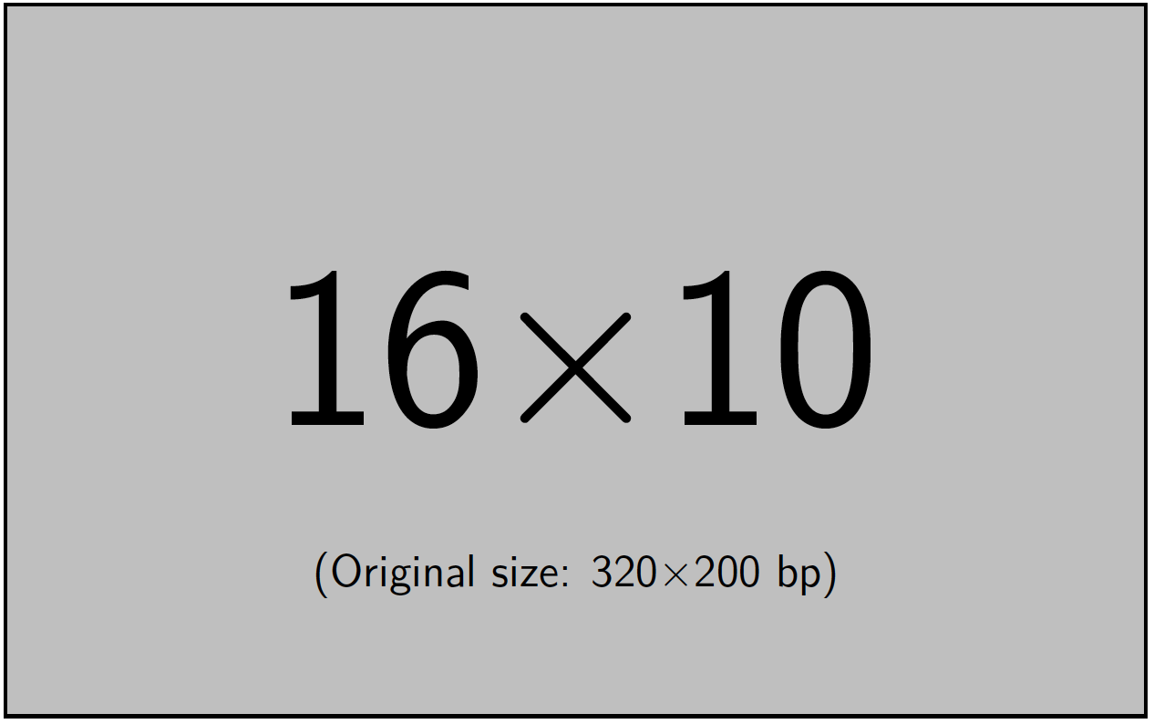
Figure 2. Insert figure caption here

Biodesign Conference Article Types
The Biodesign Conference accepts submissions in the form of Full Papers, Pictorials, and Demos. Please find instructions below. When submitting your manuscript, please ensure that you select "Biodesign Conference" from the submission menu.

Full Paper: Biodesign Conference
Full papers have no strict page limit, but their length should align with the scope and significance of their contribution. Typical submissions range from 6,000 to 8,000 words (excluding references, captions, and appendices). Submissions under 4,000 words or over 12,000 words may face desk rejection. Papers should be concise yet thorough, avoiding repetition or verbosity, while ensuring all critical details, relevant prior work, and proper formatting are included. Submissions that deviate significantly from these guidelines may be rejected. Please follow the template and leave blank author(s) and their affiliation(s) for double blind review. The abstract for the full papers should not be more than 150 words succinctly describing the background and context of the paper as well as its contribution to the Biodesign community.

Pictorial: Biodesign Conference
Pictorials should combine visual and textual content to effectively communicate research, design processes, or critical insights. Pictorials must not exceed 12 pages, excluding references. On the first page of the submission please keep with the template and include the submission’s title, author(s) and their affiliation(s) (leave blank for double blind review), and a written abstract of no more than 150 words succinctly describing the background and context of the pictorial as well as its contribution to the Biodesign community. Further written parts known from other conference formats such as Introduction, Conclusion, Discussion, Acknowledgements, and References are optional. The main part of the submission should be an annotated visual composition and we encourage submissions to use the format creatively. Pictorials and full papers will use the same template. While full papers rely more heavily on text, pictorials place greater emphasis on visual content. Please see the examples below from the ACM Designing Interactive Systems Conference (2025).

Demo: Biodesign Conference
Demo submissions should include a title that clearly states the name of the demo. An abstract (maximum 500 words) should provide a concise summary of the demo, highlighting its purpose, novelty, and key features. The demo description (maximum 2 pages) should include the objective and relevance, its significance; technical details, describing the underlying technology, setup, and requirements; and interactivity, outlining how attendees will engage with the demo. Supporting materials such as links to a short demo video, screenshots, or additional documentation are optional. Lastly, authors should specify any technical requirements, including special hardware or software needs for the presentation. Demos will undergo double blind peer review.

Authors should note the following
Articles should be submitted in a Word document or in a LaTeX file. Articles can be submitted in either American or British English. All articles submitted must contain line numbers. Up to three levels of headings are allowed. Please indicate what level each heading should be. S.I. (International System of Units) units should be used throughout in text, figures and tables. Authors should spell out in full any abbreviations used in their manuscripts the first time that they use it. Foreign quotations and phrases should be followed by a translation. Authors should provide 3 to 5 keywords for their manuscripts, except for Questions, where keywords are optional. Footnotes are not accepted in the manuscripts. Endnotes should be used instead. Note markers in body text are superscript numerals. Each note should end in a period. Dashes: En dashes should be used, with one letter space on each side. The order of parentheses should be ([ ]).
The title of the article should be short but informative and accurately reflect the content. Authors should list their first name and last name in full, plus any other initials. You should indicate the corresponding author with an asterisk and in this case provide an email address. Please also list a brief affiliation for each author (assigned with superscript numbers) below the author names. For affiliations, the country is required and there should be no street addresses. For US-based authors, states must be 2 letter postal codes not spelled out, and there should be no zip codes. Author affiliations should represent the institution(s) at which the research presented was conducted and/or supported and/or approved. For non-research content, any affiliations should represent the institution(s) with which each author is currently affiliated.

Conclusion
The conclusion text goes here.

Acknowledgments
We are grateful for the technical assistance of A. Author. You may acknowledge individuals or organisations that provided advice and/or support (non-financial). Formal financial support and funding should be listed in the Financial Support section (see below).

Funding Statement
This research was supported by grants from the funder-name doi(<award ID>); <funder-name><doi>(<award ID>). Please provide details of the sources of financial support for all authors, including grant numbers. For example, "This work was supported by the National Science Foundation (grant number XXXXXXX)". Multiple grant numbers should be separated by a comma and space, and where research was funded by more than one agency the different agencies should be separated by a semi-colon, with 'and' before the final funder. Grants held by different authors should be identified as belonging to individual authors by the authors' initials. For example, "This work was supported by the Deutsche Forschungsgemeinschaft (A.B., grant numbers XXXX, YYYY), (C.D., grant number ZZZZ); the Natural Environment Research Council (E.F., grant number FFFF); and the Australian Research Council (A.B., grant number GGGG), (E.F., grant number HHHH)".
Where no specific funding has been provided for research, please provide the following statement: "This research received no specific grant from any funding agency, commercial or not-for-profit sectors."

Competing Interests
A statement about any financial, professional, contractual or personal relationships or situations that could be perceived to impact the presentation of the work — or `None' if none exist. Authors should include a Conflicts of Interest declaration in their manuscript.
Conflicts of Interest are situations that could be perceived to exert an undue influence on an author’s presentation of their work. They may include, but are not limited to, financial, professional, contractual or personal relationships or situations.
Conflicts of Interest do not necessarily mean that an author’s work has been compromised. Authors should declare any real or perceived Conflicts of Interest in order to be transparent about the context of their work.
If the manuscript has multiple authors, the author submitting the manuscript must include Conflicts of Interest declarations relevant to all contributing authors.
Example wording for a Conflicts of Interest declaration is as follows: “Conflicts of Interest: Author A is employed at company B. Author C owns shares in company D, is on the Board of company E and is a member of organisation F. Author G has received grants from company H.” If no Conflicts of Interest exist, the declaration should state “Conflicts of Interest: None”.

Data Availability Statement
A statement about how to access data, code and other materials allowing users to understand, verify and replicate findings — e.g. Replication data and code can be found in Harvard Dataverse: \url{https://doi.org/link}.
In this journal we only accept a variation of one of the data availability statements below:
For Data openly available in a public repository, with a permanent identifier (such as a DOI): The data that support the findings of this study are openly available in [repository name] at http://doi.org/[doi], reference number [reference number].
For Data embargoed due to commercial restrictions: The data that support the findings of this study will be available in [repository name] at [URL / DOI link] following a [6 month] embargo from the date of publication, to allow for commercialisation of research findings.
For Data subject to third party restrictions: The data that support the findings of this study are available from [third party]. Restrictions apply to the availability of these data, which were used under licence for this study. Data are available [from the authors / at URL] with the permission of [third party].
For Data available within the article or its supplementary materials: The authors confirm that the data supporting the findings of this study are available within the article [and/or its supplementary materials].
For Data sharing not applicable no new data generated: Data availability is not applicable to this article as no new data were created or analysed in this study.

Ethical Standards
The research meets all ethical guidelines, including adherence to the legal requirements of the study country. This journal follows the COPE guidelines regarding ethics and as such requires that you include an Ethics Statement detailing relevant approvals such as IRB, the ethical treatment of human and animal research participants and informed consent as appropriate to the study. Further details can be found on our Publishing Ethics Page.

Author Contributions
Please provide an author contributions statement using the CRediT taxonomy roles as a guide \url{https://www.casrai.org/credit.html}. Conceptualization: A.A; A.B. Methodology: A.A; A.B. Data curation: A.C. Data visualisation: A.C. Writing original draft: A.A; A.B. All authors approved the final submitted draft.

Notes
1 A footnote/endnote
2 Another footnote/endote

References
References in text should follow the Cambridge A citation style. On the Biotechnology Design Journal website, you can find the Endnote style (n.d.) and find here Zotero style (n.d). At the end of the article, references should first be listed alphabetically, with a full title of each article, and the first and last pages. Journal titles should be given in full.
Accuracy of references is the responsibility of the author(s). References must be checked against the text to ensure (a) that the spelling of authors' names and the dates given are consistent and (b) that all authors quoted in the text (in date order if more than one) are given in the reference list and vice versa.
Please note that the DOI of the cited article must be included in the reference, the correct format being: https://doi.org/10.1017/btd.20... Exceptions exist for cited material that does not currently have a DOI.
See below for an example of how the references should be written (style: biodesign_reference list):
ACM Designing Interactive Systems Conference (2025). Examples of Pictorials. https://dis.acm.org/2026/pictorials/
Adade, C. M., de Castro, S. L., and Soares, M. J. (2007). Ultra-structural localization of Trypanosoma cruzi lysosomes by aryl sulphatase cytochemistry. Micron 38 (3): 252–256.
Bayer-Santos, E., Aguilar-Bonavides, C., Pessini Rodrigues, S., Cordero, E. M., Ferreira Marques, A., Varela-Ramirez, A., Choi, H., Yoshida, N., Da Silveira, J. F., and Almeida, I. C. (2013). Proteomic analysis of trypanosoma cruzi secretome: characterization of two populations of extracellular vesicles and soluble proteins. Journal of Proteome Research 12 (2): 883–897.
Cambridge Journals Artwork Guide (n.d). https://www.cambridge.org/core/services/authors/journals-artwork-guide
Scott, J. (2023). Living textiles. Research Directions: Biotechnology Design, 1, e6, 1-3. https://doi.org/10.1017/btd.2022.7

Example Appendix Section
Lorem ipsum dolor sit amet, consectetur adipiscing elit, sed do eiusmod tempor incididunt ut labore et dolore magna aliqua. Lorem ipsum dolor sit amet, consectetur adipiscing elit, sed do eiusmod tempor incididunt ut labore et dolore magna aliqua. Lorem ipsum dolor sit amet, consectetur adipiscing elit, sed do eiusmod tempor incididunt ut labore et dolore magna aliqua. Lorem ipsum dolor sit amet, consectetur adipiscing elit, sed do eiusmod tempor incididunt ut labore et dolore magna aliqua.
Lorem ipsum dolor sit amet, consectetur adipiscing elit, sed do eiusmod tempor incididunt ut labore et dolore magna aliqua. Lorem ipsum dolor sit amet, consectetur adipiscing elit, sed do eiusmod tempor incididunt ut labore et dolore magna aliqua.

